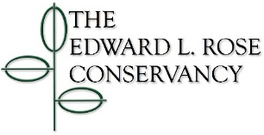

One-time Donation Form

Date: ________________________

Donation Amount (check one) *

☐ $50

☐ $100

☐ $250

☐ $500

☐ $1,000

☐ $2,000 **

☐ Other $__________________________ (please write in amount)

☐ This gift should remain anonymous

☐ This gift is in memory or honor of _________________________________

(name of friend or loved one)

☐ This gift is in support of ________________________________________

(name of E.L. Rose program or activity)

Donor Information

Name(s) _________________________________________________________________

(exactly as it/they should appear on donor lists)

Mailing Address ________________________________________________________________

City ______________________________ State ___________ Zip Code___________________

Primary Telephone ________________________________

Primary E-mail ________________________ Secondary E-mail _________________________

Please make checks payable to the Edward L. Rose Conservancy and send with this form to:

Edward L. Rose Conservancy

PO Box 8

Montrose, PA 18801-0008

* This donation does not include annual membership dues.

** A donation for an amount of $2,000 or higher would include a life-time membership.

To become a member, or to renew your membership subscription, visit elrose.org and click on the “Membership” tab. Questions? Please call our office at (570) 432-0162 or email us at board@elrose.org.

